The influence of diabetes mellitus on patients' eyes

This research was prepared by:

- Shahad Saad Abdullah
- Shaimaa Mohammed Shukr
- Ali Farhan Jasim
- Abdul Rahman Salih Hassan
Under the supervision of :Assist. Prof. Yousor Majid Jameel

This research provided a completion of the requirements for obtaining a diploma in the Optometry Department.

²⁰²⁰-²⁰²¹

اهدي اليكم بحثي هذا عن تأثير السكري على العين .

شكر وتقدير

بعد الحمد والشكر لله رب العالمين الذي مَن على الطالب بفضله وكرمه والصلاة
والسلام على الصادق الأمين محمد صلى الله عليه وسلم وآل بيته الطيبين الطاهرين
وانطلاقا من قوله صلى الله عليه وسلم : (من لا يشكر الناس لا يشكر الله) وفي
مستهل هذا البحث وعرفاناً مني بالجميل أتقدم بجزيل شكري وفائق تقديري الى
اساتذتي الأفاضل في المعهد الطبي /المنصور

اخص بالذكر منهم الأستاذ المساعد يسر ماجد جميل التي تكرمت واشرفت على هذا البحث بكل مسؤولية
وفي تسهيل مهمة الطالب وانضاج تجربة البحث العلمي وكان لها الفضل الكبير في
مساعدتنا في هذا البحث .

ولا يفوتني ان اشكر زملائي وزميلاتي في قسم فحص البصر الذين لم يبخلوا
بالنصيحة وابداء الرأي، ادعو الله لهم بالتوفيق والسداد.

واتوجه لكل من مد لي يد العون، ممن لم تسعفني الذاكرة بذكرهم بالشكر ، فجزاهم
الله عني خير الجزاء، وختاماً أسال الله العلي القدير ان يكون هذا العمل خالصاً
لوجهه وأن يجعله علما ً نافعاً ويسهل لنا به طريقا إلى الجنة.

ابنائكم الطلبة

introduction :

It is a syndrome characterized by a metabolic disorder and an abnormal high blood sugar concentration caused by insulin deficiency, decreased tissue sensitivity to insulin, or both.
It's a complex, serious and chronic (long-term) health condition that may have significant effects on many parts of the body, including the eyes, nerves, brain, kidneys, heart, and extremities. To a large extent, these effects are caused by damage to blood vessels.
The important aspect of diabetes is that although it cannot be cured, the vast majority of people who have the disease can reduce or avoid its complications and health problems associated with it, through perfect control of blood glucose levels, good care for diet, weight control and regular physical activity.
Diabetes is a very dangerous condition, and it requires daily self-control and personal responsibility for it, including controlling blood glucose levels, blood pressure and blood lipids by maintaining a healthy weight, eating a healthy diet, and carrying out health-beneficial activities.

Diabetes types :

Type I Diabetes mellitus:
is considered one of the autoimmune diseases, which is the immune system’s production of antibodies that attack the body by mistake, and in the event of diabetes, the antibodies attack the cells of the pancreas that produce the hormone insulin and inhibit their ability to produce it, which leads to high blood sugar, and this type of Diabetes accounts for 5-10% of all types of diabetes, according to what was published in the Journal of Diabetes Care. In 2009, issued by the American Diabetes Association, and in most cases the symptoms of this type of diabetes appear before the person reaches the age of thirty, and this type was previously known as insulin-dependent diabetes or juvenile diabetes, and it should be noted that in the absence of body cells capacity On the use of glucose to produce energy due to the absence of insulin, the body depends on burning fat to produce energy, which causes the accumulation of harmful chemical compounds in the body, and these compounds are known as ketones, and therefore adherence to the treatment prescribed by the doctor is very important to prevent these complications.

Causes :
Scientists have not been able to determine the main cause that leads to the immune cells in the body attacking the cells that produce insulin, and it is believed that there are some factors that increase the risk of developing the disease, such as:
- Family history: The presence of one of the parents or brothers with diabetes increases the chance of suffering from This disease.
- Genes: It is believed that there are genes associated with type 1 diabetes, and that carrying them increases the chance of developing the disease.
- Age: Although diabetes is possible at any age, most cases appear in the age period ranging from four to seven years, as well as between 10-14 years.

Treatment:-
The treatment of type 1 diabetes depends on giving insulin to the sufferer several times a day to help regulate the level of sugar in the blood, and it is possible to give insulin in the form of an injection or pump.

Type II Diabetes mellitus:

It can be defined as insulin resistance By the different cells of the body or not responding to insulin, which causes the blood sugar level to rise due to its inability to enter the cells.
this is what alerts the pancreas to produce more insulin, and in some cases the stress of the pancreas resulting from this condition may lead to a decrease in its ability to Gradual insulin production, which in turn leads to an increase in the problem of high blood sugar worsening.
type 2 diabetes is the most common type of diabetes, accounting for approximately 90-95% of all diabetes cases, according to what was published in the Journal of Diabetes Care in 2009 issued by the American Diabetes Association.

and it is worth mentioning that the incidence of type 2 diabetes is more common with advancing age. However, the incidence of younger people is increasing as a result of the following an unhealthy diet, low physical activity, and suffering from Obesity.

Causes :
The main cause that leads to cell resistance to insulin or impaired production of insulin by the pancreas has not yet been determined, but there are a group of factors that increase the risk of developing type 2 diabetes, and some of them are explained below:
Advancing age: The risk of developing disease increases Diabetes with advancing age, especially after the age of forty-five, and this may be attributed to a decrease in physical activity of a person, weight gain, and a decrease in muscle mass.
Genetics: It is one of the most important risk factors associated with type 2 diabetes, as the risk of developing the disease increases if there is a family history of type 2 diabetes.
Obesity: Obesity and excess weight are one of the most risk factors that increase the chance of developing type 2 diabetes, represented by a high BMI of 30 or more, especially in the case of excess fat in the abdominal area, because these fats cause the production of some chemical elements that lead To disturbance of metabolic processes and the circulatory system in the body.

treatment :
The treatment of type 2 diabetes depends mainly on following a healthy lifestyle, which is to lose excess weight, regularly monitor blood sugar, exercise, and follow a healthy diet, and it should be noted that the loss ranges between 5-10% of weight It may help to regulate the level of sugar, and in some cases where the affected person suffers from severe obesity, he may need to undergo one of the types of bariatric surgery to help lose weight, and make sure to exercise on an almost daily basis, ranging between 30-60 minutes to help In fact, diabetes can be controlled by making these lifestyle adjustments only, while there are cases in which the patient needs treatment with insulin or other medications.

Type III Gestationdl Diabetes Mellitus :
Gestational diabetes can be defined as one of the types of diabetes in which blood sugar rises above the normal rate during pregnancy in some women, due to increased resistance of cells to insulin or a decrease in insulin production. and it should be noted that this type of diabetes can be controlled in most cases. Where women affected by it can complete their pregnancy naturally and give birth to healthy children.
Causes :
Gestational diabetes occurs as a result of the placenta producing some hormones that contribute to an increase in blood sugar levels, and in normal cases the pancreas is able to produce more insulin to maintain the normal level of blood sugar, while in other cases the pancreas is not able to increase production Insulin is proportional to the amount of sugar produced, and then a pregnant woman suffers from gestational diabetes, and among the factors that increase the risk of developing this type of diabetes is any of the following:

- Obesity or excess weight before pregnancy.
- High blood pressure or some other disease.
- family history of diabetes.
- having a child weighing more than four kilograms in a previous pregnancy.
- The birth of a child with birth defects in a previous pregnancy.
- Having PCOS
- Having pre diabetes.
- The pregnant woman is over 25 years old

treatment :

Treatment of gestational diabetes is based on high blood sugar levels, and it can be controlled by making some changes to the pregnant woman's lifestyle only. Such as practicing appropriate exercise and eating a healthy diet, while in some other cases a pregnant woman may also need to use some drug treatments such as metformin and glibenclamide or The use of insulin, according to what the specialist doctor deems appropriate.

* in the absence of appropriate treatment, this may lead to some health complications for the pregnant woman and the fetus, and gestational diabetes usually disappears after childbirth for most women. But it generally increases the chance of developing type 2 diabetes in the future.

Diabetes Diagnosis :

- Clinical symptoms: frequent urination, thirst, emaciation, weight loss, increased appetite, fatigue, wound failure, recurrent infections.
- Hemoglobin A1C( HBA1C )test: This is a blood test to detect the level of sugar in the blood during the previous three months.
- Blood sugar test: It is a normal blood test that is taken regularly.
- Fasting test: A blood sample is taken after fasting for about 8 hours, in order to measure the level of sugar in the blood

Diabetes complications:

There are three severe complications, important and serious that require good care, that occur in diabetics:
1. Hypoglycemia.
2. Severe high blood sugar.
3. Diabetic ketoacidosis

effect of diabetes on the eye

Diabetes can affect the eyes in several ways:
- cloud transient vision: Unusual changes can affect blood glucose levels as a result of diabetes in the shape of the lens inside the eye, which changes the focus, especially when blood glucose levels are high. This results in a blurred vision, which comes and goes during the day, according to blood glucose levels. This effect is generally short-lived, but for some people it may last for several months.
- Diabetic Retinopathy: The most common and most dangerous eye disease caused by diabetes. It is the leading cause of blindness for people of working age
- Cataract: One of the long-term effects of diabetes is clouding of the eye's lens. This condition is called cataract. Cataract can form in anyone, but it occurs more frequently and at an earlier age in people with diabetes.
- Glaucoma: Diabetes increases the likelihood of developing glaucoma as a result of progressive damage to the optic nerve at the back of the eye. While this occurs slowly and without symptoms in the early stages, it can lead to blindness if not detected and treated effectively.
Diabetic Retinopathy :

Diabetic retinopathy is a complication of diabetes in the eye.
This disease is caused by damage to the blood vessels of the light-sensitive tissue in the back of the eye (retina).
Initially, diabetic retinopathy may cause no symptoms or cause only minor vision problems.
Ultimately, it can cause blindness.

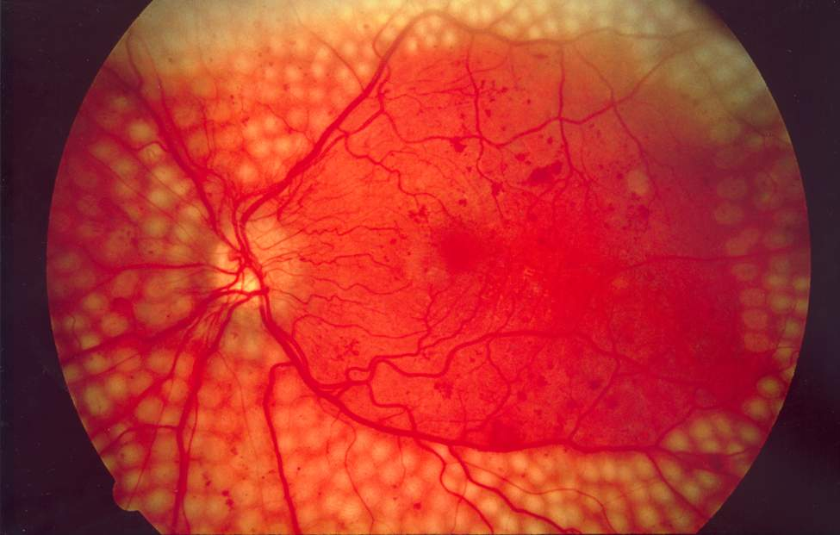
Diabetic retinopathy

Causes:

Continuously high blood sugar causes disturbances in the walls of the small blood vessels of the retina, which become permeable and distorted, which leads to the progression of retinopathy in varying stages.

Symptoms :

Usually, there are no early symptoms or signs of diabetic retinopathy, and a person's vision may not be affected until his condition worsens.
Normal Diabetic Retinopathy

Symptoms of this disease include:
- Lack of central vision when reading or driving a car
- Loss of color vision
- Blurred or cloudy vision
- Small spots (such as floating objects in the field of vision)

Diagnosis :
Diabetic retinopathy is best diagnosed with a comprehensive eye exam. During this examination, eye drops are placed in your eyes to dilate the pupil to enable the doctor to see better inside your eyes. The drops may cause blurry vision, but they wear off after several hours.
Ophthalmoscopy is an examination of the retina in which the eye care professional On funduscopic exam, a doctor will see cotton wool spots, flame hemorrhages, and dot-blot hemorrhages.
Fundus fluorescein imaging By expanding your eyes, your doctor takes pictures from inside your eyes. Then your doctor will inject a special dye into a vein in your arm and take more pictures as the dye travels through the blood vessels in your eyes. Your doctor can use the images to identify blood vessels that are blocked, broken, or leaking fluid.
treatment :

Treatment tends to slow or prevent the condition from progressing and is largely dependent on the type of diabetic retinopathy you have and how severe it is.
- Early diabetic retinopathy
If your non proliferative diabetic retinopathy is mild or moderate, you may not need to get treatment right away. However, the ophthalmologist will closely monitor your eyes. To determine if you need treatment.
Work with your diabetes doctor to determine if there is any way to improve the way you manage diabetes. Usually, the condition can be slowed by good blood sugar control if the diabetic retinopathy is mild or moderate
- Advanced diabetic retinopathy
If you have proliferative retinopathy or macular edema, you will need surgical treatment right away. Depending on the specific problems in the retina, options may include:
- Photo coagulation: This laser treatment, also known as focal laser therapy, can stop or slow the leakage of blood and fluid in the eye. During the procedure, leaks of abnormal blood vessels are treated with a laser burn.
- Photo coagulation of the whole retina: This treatment with laser beams, also called scattered laser beam therapy, can cause the abnormal blood vessels to shrink. During the procedure, areas of the retina far from the macula are treated with scattered laser burns. The burns cause the abnormal new blood vessels to shrink and scar. Treatment is usually performed in two or more sessions at a doctor's office or eye clinic. Your vision will be cloudy for about one day after the procedure. It's possible that your peripheral vision or night vision will lose some degree after the procedure.

- eradication Vitreous : This procedure uses a very small incision in the eye. To remove blood from the center of the (vitreous) eye, as well as scar tissue affecting the retina. This procedure is performed in a surgical center or hospital, using general or local anesthesia.

- Inject the medicine into the eye : Your doctor may suggest that a drug be injected into the eye vitreous. These drugs, called vascular endothelial growth factor (VEGF) inhibitors, may help stop the growth of new blood vessels by blocking the effects of the growth signals the body sends to create new blood vessels.
Risk factor :

- All people with diabetes
- Women diagnosed with gestational diabetes
- Family history
- High blood glucose
- Duration of diabetes
- Smoking and tobacco use

Protection :

You can't always prevent diabetic retinopathy. However, regular retinal exams, good blood sugar and blood pressure regulation, and early intervention to resolve vision problems can help prevent severe vision loss.
If you have diabetes, reduce your risk of developing diabetic retinopathy by doing the following:
- Control your sugar. Make healthy eating and physical activity a part of your daily routine
- .Monitor your blood sugar level.
- Keep blood pressure and cholesterol levels under control.

conclusion

In a clinical guideline published in late May, it announced what would be the most radical change in the treatment of type 2 diabetes in nearly a century. The directions appeared in Diabetes Care .Diabetes Care, Issued by the American Diabetes Association, and has been endorsed by about 45 professional societies around the world,
and has proposed that the surgical procedure to alter the stomach and intestine be considered a standard treatment option for patients that are suitable for this procedure. This development comes after a number of ,clinical trials
which have shown that gastrointestinal surgery is able to improve blood sugar levels more effectively than following a certain lifestyle or drug intervention, so that it leads to the disappearance of signs and symptoms of the disease in the long term, which is known medically. Silence of disease remission.

As someone who has researched the nature of the relationship between gastrointestinal surgery and glucose homeostasis, since the late 1990s, I have witnessed first-hand how reaching this point has necessitated the abandonment of many clinical scientists who specialize in clinical research abandoning long-standing preconceptions. In fact, these guidelines emerged nearly 100 years after the first clinical observations of the potential to improve diabetes or even

solve the problem with surgery. Evidence that surgery can stimulate disease remission, which has long been considered an irreversible disease, may reinforce studies looking into determining the causes of diabetes and even renewing hopes for a cure. However, future progress will require more creative and atypical thinking.

Sources and references:-

1. Nsiah-Kumi, P., Ortmeier, S. R., & Brown, A. E. (2009). Disparities in Diabetic Retinopathy Screening and Disease for Racial and Ethnic Minority Populations—A Literature Review. Journal of the National Medical Association, 101(5), 430–438.

2. Carpenter MW, Coustan DR: Criteria for screening tests for gestational diabetes. Am J Obstet Gynecol: (Pp768 – 773)1982

3. Pardianto G (2005). "Understanding diabetic retinopathy". Mimbar Ilmiah Oftalmologi Indonesia. 2: 65–6.

4. Catherine H, Wendy L (May 8, 2018). "Preventing blindness in sight". San Francisco Chronicle.

5. Kertes PJ, Johnson TM, eds. (2007). Evidence Based Eye Care.

6. Tierney, S J McPhee, M A Papadakis (2002). Current medical diagnosis & treatment.

7. Diabetes Solution: The Complete Guide to Achieving Normal Blood Sugars

8. Expert Committee on the Diagnosis Classification of Diabetes Mellitus

9. Nonproliferative Diabetic Retinopathy (Includes Macular Edema)

10. Retinopathy | Definition of Retinopathy by Oxford Dictionary

11. Unite for Diabetes
الخاتمة:-

الحمد لله تعالى الذي وفقنا في تقديم هذا البحث، وها هي القطرات الأخيرة في مشوار هذا البحث والمشوار الدراسي، وقد كان البحث يتكلم عن (تأثير داء السكري على العين)، وقد بذلنا كل الجهد والبذل لكي يخرج هذا البحث في هذا الشكل.

ونرجو من الله أن تكون رحلة ممتعة وشيقة بوجود الجمع الكريم من الأساتذة وزملائنا الطلبة، وكذلك نرجو أن تكون قد أرتقت بدرجات العقل والفكر، حيث لم يكن هذا الجهد بالجهد اليسير، ونحن لا ندعى الكمال فإن الكمال لله عز وجل فقط، ونحن قدمنا كل الجهد لهذا البحث، فإن وفقنا فمن الله عز وجل وإن أخفقنا فمن أنفسنا، وكفانا نحن شرف المحاولة، واخيراً نرجو أن يكون هذا البحث قد نال إعجابكم.

وصل اللهم وسلم تسليما كثيراً وبارك على معلمنا الأول وحبيبنا سيدنا محمد عليه أفضل الصلاة والسلام ...

أبنائكم الطلبة

